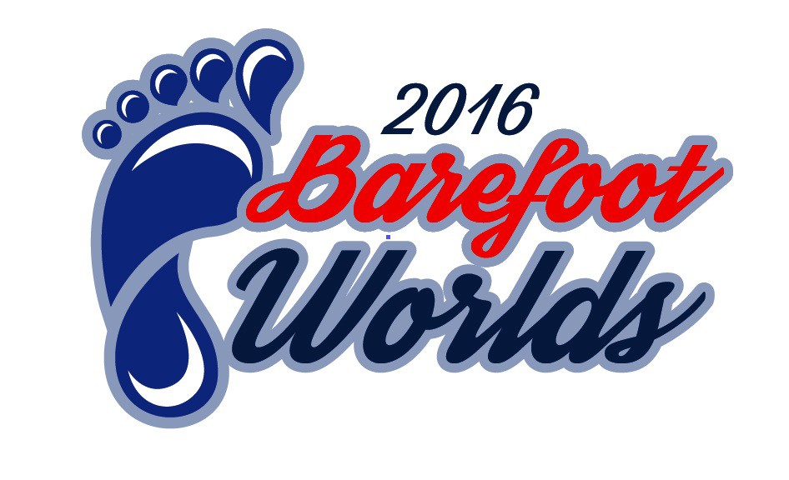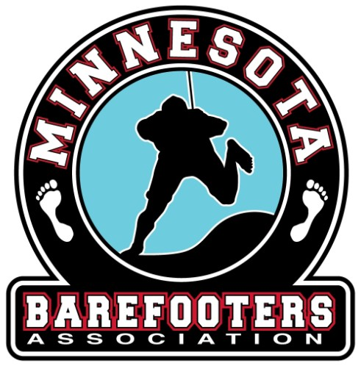

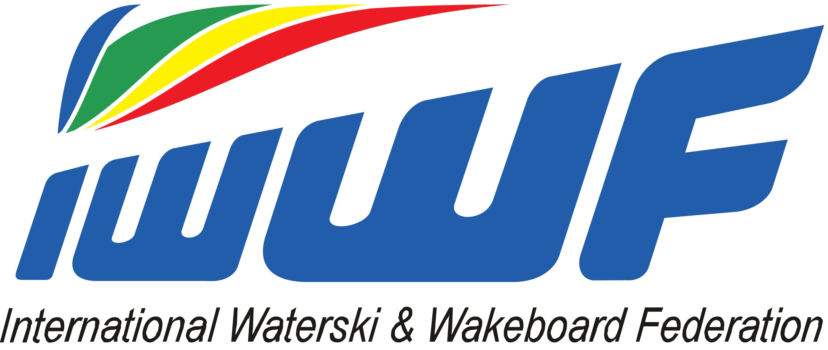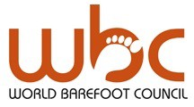2016 World Barefoot Water Ski Championships
presented by Bank First
August 13-20 Alma Center, WI USA
DEFINITIVE ENTRY FORM

Return the forms to the Local Organizing Committee Registrar, Confederation Barefoot Council Chairman,
ENTERING AS | SLALOM | TRICKS | JUMP
 | JR / SR / Open | JR / SR / Open | JR / SR / Open
Team Member in:
Reserve Team Member in:
Individually Qualified skier in:

and the WBC Chairman at least 4 weeks prior to the 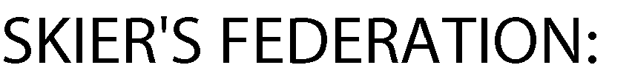 start of competition.

Deadline: July 17th, 2016
LOC Registrar: registrar@mnbarefoooters.org

Any Federation not meeting these requirements will not be allowed to compete until the Federation pays to the WBC a fine of $10 (USD) per skier per day after the four week deadline, for each skier not officially entered.

Doping control

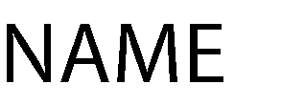In accordance with the IWWF anti-Doping Rules, Doping controls will be conducted during the competition. By entering this competition, all athletes agree to be subject to doping control.
Information about the IWWF Anti-Doping program, the current IWWF AD Rules and links to the list of banned substances can be found on http://www.iwwfed.com/ by clicking the Anti-Doping Information link at the top of the menu on the left sidebar of the homepage.

